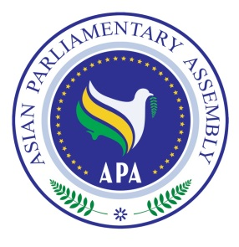
Asian Parliamentary Assembly

Standing Committee on Social and Cultural Affairs
And
Meeting of APA Women Parliamentarian

5 October 2018
Izmir – Turkey

Draft Agenda
1- Adoption of the Agenda,
2- Election of the Bureau,
3- Opening Remarks by Chairperson of the Meeting,
4- Report of APA Secretary General
5- Deliberation on situation of Women Parliamentarian in Asia
6 - Consideration and recommendation of Draft Resolutions
7- Any other matters.

As of 1 September 2018

